Team’s Name: Pipotam
1. Problem Statement
Modern secure-messaging and file-sharing systems such as Signal, WhatsApp, iMessage, and most enterprise chat/cloud-vault products rely on classical public-key cryptography. They use Elliptic Curve Diffie-Hellman (X25519) for key agreement and EdDSA/ECDSA/RSA for digital signatures. These are used inside a Double Ratchet architecture to provide forward secrecy and post-compromise security.
The security of X25519, ECDSA, and RSA depends on the difficulty of solving the discrete-logarithm and integer-factorisation problems. However, Shor’s algorithm, when run on a sufficiently large fault-tolerant quantum computer, can solve both of these problems in polynomial time. This means that these cryptographic primitives — and the messages, key bundles, or files protected using them — could become breakable once such a quantum computer exists.

Therefore, the problem addressed by this project is:
How can we redesign a real-time, forward-secret, asynchronous messaging and file-vault protocol so that its key-establishment, ratcheting, and signature layers remain confidential and authentic even against an adversary equipped with a cryptographically relevant quantum computer (CRQC), while still keeping the same usability, latency, and offline-message guarantees provided by Signal-style systems today?
The assets at risk include end-to-end encrypted chat content, voice/video call keys, shared files and documents stored in the vault, identity and prekey bundles stored on relay servers, and the long-term identity keys of users, groups, or organisations using the protocol.

2. Significance of the Problem
This is an urgent cybersecurity problem because of the "Harvest-Now, Decrypt-Later" (HNDL) threat model: an adversary can record encrypted traffic and stored file-vault ciphertext today and decrypt it retroactively the moment a CRQC becomes available. For data with a long confidentiality shelf-life -- government and defence communications, healthcare records, legal documents, intellectual property, financial records, and personal messages -- a future break is just as damaging as a break today.
Standards bodies already treat this as time-critical: NIST finalised the first Post-Quantum Cryptography standards (FIPS 203 ML-KEM, FIPS 204 ML-DSA, FIPS 205 SLH-DSA) in August 2024, and the U.S. NSA's CNSA 2.0 suite mandates PQC algorithms for new National Security Systems on a fixed migration timeline.
The risks of inaction span several dimensions:
- Confidentiality risk -- HNDL exposes archived ciphertext;
- Authentication risk -- forged ML-DSA-less signatures would let an attacker impersonate identities or inject malicious files/messages once classical signatures are broken;
- Forward-secrecy erosion -- a compromised long-term key in a purely classical ratchet exposes past sessions retroactively if the transcript was harvested;
- Ecosystem risk -- millions of users of Signal-protocol-based apps (WhatsApp, Signal, Google Messages RCS) and enterprise vault products depend on exactly the primitives that quantum computers threaten;
- Transition risk -- a naive "rip and replace" of classical algorithms with untested PQC algorithms could itself introduce new vulnerabilities, since newer lattice-based schemes have a shorter cryptanalytic track record. A well-engineered, standards-based hybrid transition is therefore both a confidentiality/integrity necessity and a risk-management necessity.

3. Literature Survey
Existing Solution | How It Works | Advantages | Limitations
Signal Protocol (Double Ratchet + X3DH, Signal/WhatsApp/Google Messages) | X3DH performs an initial ECDH-based handshake using Curve25519; the Double Ratchet then combines a Diffie-Hellman ratchet with a symmetric-key KDF chain to derive a fresh key for every message. | Strong forward secrecy and post-compromise security; open-sourced, formally analysed, and battle-tested in production at massive scale. | Every key-agreement and ratchet step relies purely on elliptic-curve Diffie-Hellman, which Shor's algorithm breaks completely once a CRQC exists; offers no quantum resistance.
TLS 1.3 with Hybrid PQC KEM (Chrome, Cloudflare, AWS -- X25519Kyber768) | Combines a classical X25519 ECDH exchange with a ML-KEM/Kyber encapsulation in the same handshake; the two shared secrets are concatenated before key derivation. | Already deployed at Internet scale; hybrid design keeps classical security as a fallback while adding quantum resistance; based on the now-finalised FIPS 203 standard. | Designed for transport-layer, session-based connections, not for asynchronous, multi-device, offline-capable messaging; has no notion of a long-lived ratchet or file vault.
OpenPGP / GPG | Uses RSA or ECC for encryption and signing of e-mail and files; keys are long-lived and manually managed by users or a keyserver. | Mature tooling, wide adoption for file/e-mail encryption, supports offline signing and detached signatures. | No forward secrecy (a single compromised private key exposes all past ciphertexts); purely classical algorithms; poor usability for real-time chat; no standardized PQC key type yet in common clients.
Matrix Olm/Megolm | Olm implements a Double-Ratchet variant over Curve25519 for 1:1 sessions; Megolm provides a ratcheting group-key mechanism for rooms. | Decentralized, federated architecture; good group-messaging performance; open specification. | Same reliance on Curve25519 ECDH as Signal's protocol -- fully vulnerable to a CRQC; no PQC migration path standardized yet.
Signal PQXDH (production, 2023) | Hybridizes only the initial X3DH handshake, combining an X25519 ECDH exchange with a Kyber-1024 KEM encapsulation; the two shared secrets are combined via HKDF to seed the very first Root Key. | Already deployed at scale in production Signal clients; proves hybrid PQC handshakes are practical on mobile devices. | Only the one-time initial handshake is hybridized — every subsequent Diffie-Hellman ratchet turn remains pure X25519, so post-compromise "healing" after session start stays fully classical and vulnerable to a CRQC.

4. Proposed Solution Approach
We propose a Hybrid Post-Quantum Double Ratchet (HPQ-DR) protocol: the existing Signal-style Double Ratchet is retained for its proven forward-secrecy and post-compromise-security properties, but every asymmetric operation is upgraded to run in hybrid mode -- classical elliptic-curve cryptography combined with NIST-standardised PQC -- so the system is secure as long as at least one of the two underlying hard problems (ECDLP or Module-LWE/Module-SIS) remains unbroken.
Basic idea of the proposed solution: -
The overall Signal-style Double Ratchet structure is retained, while its asymmetric key-exchange components are upgraded to hybrid mode. Instead of X25519 alone, the protocol runs a hybrid X25519 + ML-KEM-768 exchange, and the two resulting shared secrets are combined with HKDF to derive the Root Key and Chain Key. ML-DSA-65 replaces classical signatures for all authentication -- identity keys, prekey bundles, and file manifests.
Major components / steps: -
- Identity & Prekey generation -- each client generates an ML-DSA-65 signing keypair (long-term identity), an X25519 keypair, and a batch of one-time ML-KEM-768 encapsulation-key prekeys; the prekey bundle is signed with ML-DSA-65 before publication to the relay server.
- Hybrid initial handshake (PQXDH-style) -- the initiator fetches the receiver's signed prekey bundle, verifies the ML-DSA-65 signature, performs an X25519 ECDH exchange and an ML-KEM-768 encapsulation against the receiver's prekey, and derives the initial Root Key and Chain Key via HKDF over both shared secrets.
- Hybrid asymmetric ratchet -- periodically, on a new ratchet turn (not on every message), each party generates a fresh X25519 secret and a fresh ML-KEM-768 secret; HKDF mixes both into the current state to update the Root Key and seed a new Chain Key. This gives post-compromise security ("healing") against a quantum-capable attacker.
- Symmetric-key ratchet -- for every message, the current Chain Key is passed through a KDF to produce a Message Key and the Next Chain Key. The Message Key encrypts exactly one message and is then discarded; the Next Chain Key feeds the following message. This gives forward secrecy, and stays quantum-resistant since Grover's algorithm gives only a quadratic (not exponential) speed-up against symmetric primitives.
- Authenticated encryption & signing -- each message (or file manifest) is encrypted with AES-256-GCM / ChaCha20-Poly1305 under the message key and then signed with the sender's ML-DSA-65 identity key so the receiver can cryptographically verify sender authenticity and message integrity.
- Quantum-resistant secure vault -- large files are chunked; each file gets a fresh random AES-256-GCM data-encryption key, which is itself wrapped (encrypted) under the intended recipient's ML-KEM-768 public key; the encrypted chunks plus signed manifest are uploaded to a zero-access relay/storage server that never sees plaintext or unwrapped keys.

How the solution works: -
The session begins with the hybrid X25519 + ML-KEM-768 handshake, which produces the initial Root Key and Chain Key. The Hybrid Asymmetric Ratchet refreshes the Root Key periodically, on each new ratchet turn -- not on every message. Independently, the Symmetric-Key Ratchet advances on every message: it derives a fresh Message Key from the current Chain Key and immediately rolls the Chain Key forward.
Each message is encrypted under its own Message Key and signed with ML-DSA-65, then sent through a relay server that only stores and forwards ciphertext. On receipt, the peer verifies the signature, derives the matching key from its mirrored ratchet state, and decrypts. Files follow the same trust model, except the file's AES key is wrapped once with ML-KEM-768 rather than being derived from the ratchet.

How it addresses the identified problem: -
Because every long-term and ephemeral asymmetric operation now includes an ML-KEM-768/ML-DSA-65 component standardised under NIST FIPS 203/204, recorded handshakes and ciphertext can no longer be broken purely by a future CRQC running Shor's algorithm -- defeating the Harvest-Now-Decrypt-Later threat.
The hybrid (not PQC-only) design means confidentiality is never weaker than today's classical Double Ratchet, so a hypothetical future weakness in the lattice assumptions does not regress security below the current baseline. Retaining the double-ratchet structure preserves forward secrecy and post-compromise security, and ML-DSA-signed prekey bundles / file manifests close the authentication gap that would otherwise let a quantum attacker forge identities or tamper with vault contents.

Proposed Solution Diagram/Flowchart: -

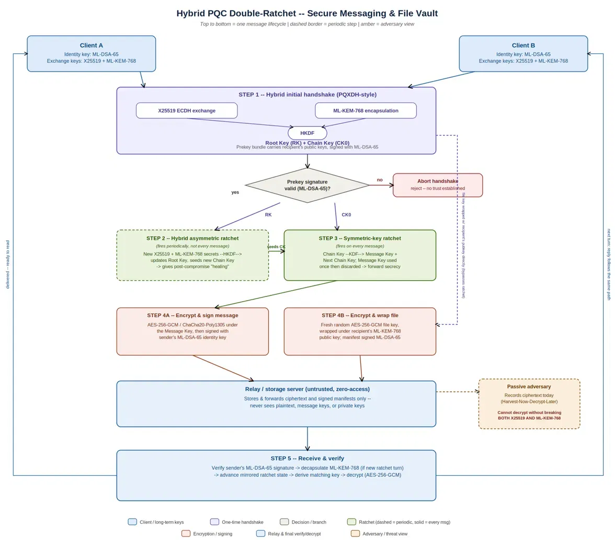
Figure: End-to-end flow of the hybrid ML-KEM/ML-DSA double-ratchet protocol for messages and the file vault.

5. Justification of the Proposed Approach
The hybrid ML-KEM/ML-DSA double-ratchet design is suitable because it targets the gaps exposed in the literature survey rather than discarding what already works. The overall Double Ratchet structure is retained because its forward-secrecy and post-compromise-security guarantees are already well established; only the asymmetric cryptographic components are upgraded, so the engineering risk of the migration is confined to well-scoped, independently-auditable modules rather than a full protocol rewrite.
Choosing ML-KEM-768 and ML-DSA-65 specifically is justified because both are finalised NIST standards (FIPS 203 and FIPS 204, August 2024) whose security rests on the Module-LWE and Module-SIS lattice problems, for which no efficient quantum algorithm is currently known, and both ship with reference and hardware-accelerated implementations (liboqs, BoringSSL, OpenSSL 3.2+) that keep handshake latency and key sizes practical for mobile clients. We deliberately target NIST Security Category 3 (ML-KEM-768 / ML-DSA-65) rather than the Category 5 parameter sets (ML-KEM-1024 / ML-DSA-87) that CNSA 2.0 mandates for National Security Systems, since Category 3 offers a better latency/key-size trade-off for a consumer messaging and file-vault use case. A CNSA-2.0-compliant deployment for government or defence users would substitute the 1024/87 parameter sets at the cost of larger handshakes and signatures.
Running these PQC primitives in hybrid combination with X25519/Ed25519 -- rather than a PQC-only construction, as some early prototypes attempted -- directly closes the "transition risk" gap noted in Section 2: even if a future cryptanalytic advance weakens lattice-based schemes, security degrades no lower than today's classical baseline, whereas a PQC-only design would have no such fallback. Unlike Signal's own PQXDH, which hybridizes only the initial handshake and leaves every later ratchet turn as pure X25519, HPQ-DR hybridizes the ratchet itself, so post-compromise healing stays quantum-resistant for the whole session, not just at setup.
Signing prekey bundles and file manifests with ML-DSA-65 closes the authentication gap left by OpenPGP/GPG-style systems, which have no forward secrecy, and by TLS-only PQC deployments, which solve the transport problem but not the asynchronous, multi-device, offline-message problem that Matrix Olm/Megolm and Signal-style apps must handle.
The expected benefits are:
- Quantum resistance for both confidentiality and authenticity, defeating Harvest-Now-Decrypt-Later.
- Unchanged forward secrecy and post-compromise security from the retained ratchet.
- A drop-in migration path that existing Signal-protocol-based apps (WhatsApp, Google Messages, Signal) can adopt incrementally by version-negotiating hybrid mode.
- A zero-access file vault where neither the relay server nor a future quantum adversary intercepting stored ciphertext can recover file contents without the recipient's ML-KEM-768 private key.

6. References
- National Institute of Standards and Technology, "Module-Lattice-Based Key-Encapsulation Mechanism Standard," FIPS PUB 203, Aug. 2024.
- National Institute of Standards and Technology, "Module-Lattice-Based Digital Signature Standard," FIPS PUB 204, Aug. 2024.
- National Institute of Standards and Technology, "Stateless Hash-Based Digital Signature Standard," FIPS PUB 205, Aug. 2024.
- J. Bos, L. Ducas, E. Kiltz, T. Lepoint, V. Lyubashevsky, J. M. Schanck, P. Schwabe, G. Seiler, and D. Stehle, "CRYSTALS -- Kyber: A CCA-Secure Module-Lattice-Based KEM," IEEE European Symposium on Security and Privacy (EuroS&P), 2018.
- L. Ducas, E. Kiltz, T. Lepoint, V. Lyubashevsky, P. Schwabe, G. Seiler, and D. Stehle, "CRYSTALS -- Dilithium: A Lattice-Based Digital Signature Scheme," IACR Transactions on Cryptographic Hardware and Embedded Systems, 2018.
- T. Perrin and M. Marlinspike, "The Double Ratchet Algorithm," Signal Technical Documentation, 2016.
- M. Marlinspike and T. Perrin, "The X3DH Key Agreement Protocol," Signal Technical Documentation, 2016.
- E. Kret and R. Schmitt, "The PQXDH Key Agreement Protocol," Signal Technical Documentation, 2023.
- National Security Agency, "Commercial National Security Algorithm Suite 2.0," CNSA 2.0 Advisory, 2022.
- Open Quantum Safe Project, "liboqs: C library for quantum-safe cryptography," openquantumsafe.org.
- Cloudflare Blog, "Post-Quantum Cryptography for TLS," blog.cloudflare.com.

